**Amazon Sagemaker Notebook Instances**

An *Amazon SageMaker notebook instance* is a ML compute instance running the Jupyter Notebook App. SageMaker manages creating the instance and related resources. Use Jupyter notebooks in your notebook instance to prepare and process data, write code to train models, deploy models to SageMaker hosting, and test or validate your models.

The notebook instance type you choose depends on how you use your notebook instance. You want to ensure that your notebook instance is not bound by memory, CPU, or IO. If you plan to load a dataset into memory on the notebook instance for exploration or preprocessing, we recommend that you choose an instance type with enough RAM memory for your dataset. This would require an instance with at least 16 GB of memory (.xlarge or larger). If you plan to use the notebook for compute intensive preprocessing, we recommend you choose a compute-optimized instance such as a c4 or c5.

**To create a SageMaker notebook instance:**

Open the SageMaker console at <https://console.aws.amazon.com/sagemaker/>.

Click on **Amazon SageMaker** from the list of all services by entering *Sagemaker* into the **Find services** box. This will bring you to the Amazon SageMaker console homepage. In another browser tab navigate to the **IAM** console homepage, as we’ll need that shortly.

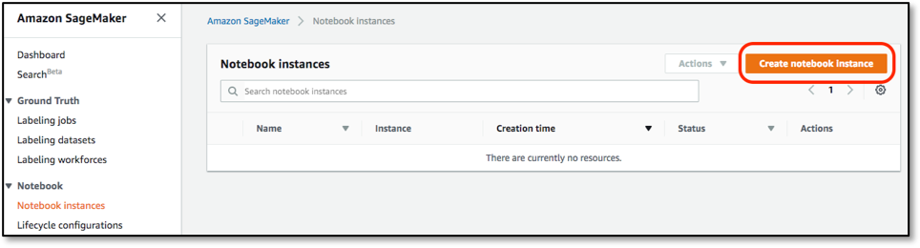

On the **Create notebook instance** page, provide the following information:

1. For **Notebook instance name**, type a name for your notebook instance. Here example I’ve given Hitesh as an instance name You can choose your own Naming Conventions.
2. For **Notebook instance type**, choose an instance size suitable for your use case. I’ve chosen here **ml.t3.medium** you can select on your own according to your requirements, a list of supported instance types and quotas, see [Amazon SageMaker Service Quotas](https://docs.aws.amazon.com/general/latest/gr/sagemaker.html#limits_sagemaker).
3. For **Platform Identifier**, choose a platform type to create the notebook instance on. This platform type dictates the Operating System and the JupyterLab version that your notebook instance is created with. For information about platform identifier type, see Amazon Linux 2 notebook instances. In my case it is **Amazon Linux 2 , Jupyter Lab 3**

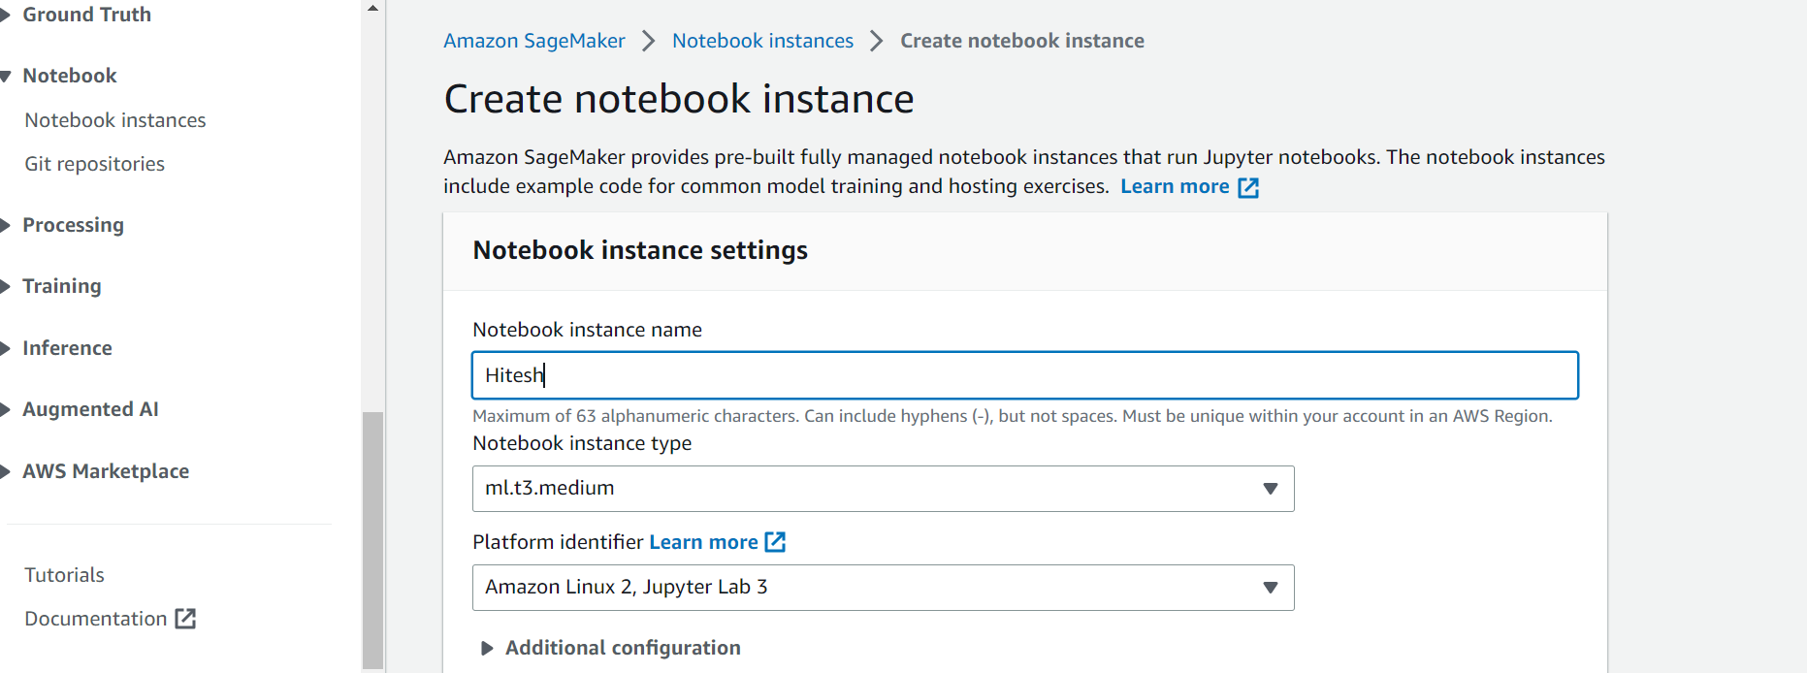

1. or **IAM role**, choose either an existing IAM role in your account that has the necessary permissions to access SageMaker resources or choose **Create a new role**. If you choose **Create a new role**, SageMaker creates an IAM role named AmazonSageMaker-ExecutionRole-*YYYYMMDD*T*HHmmSS*. The AWS managed policy AmazonSageMakerFullAccess is attached to the role. The role provides permissions that allow the notebook instance to call SageMaker and Amazon S3.
2. For **Root access**, to enable root access for all notebook instance users, choose **Enable**. To disable root access for users, choose **Disable**.If you enable root access, all notebook instance users have administrator privileges and can access and edit all files on it.

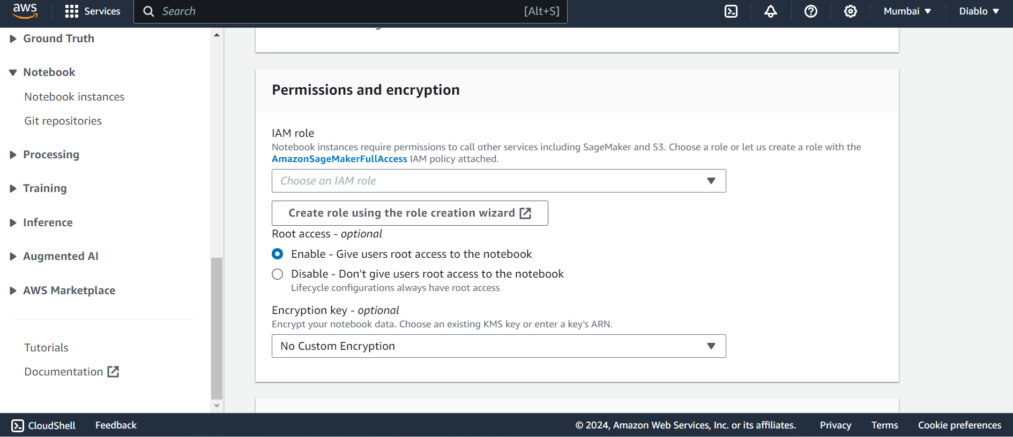

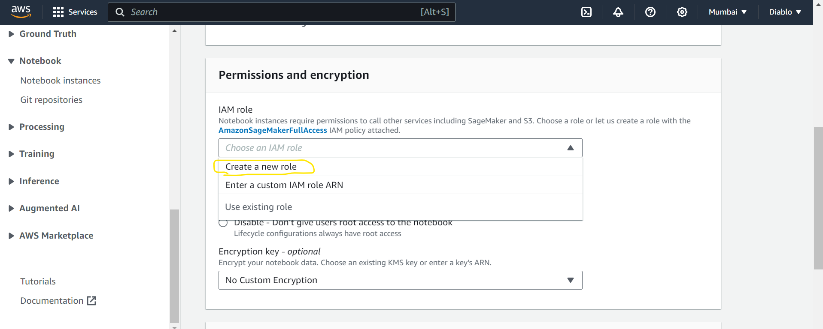

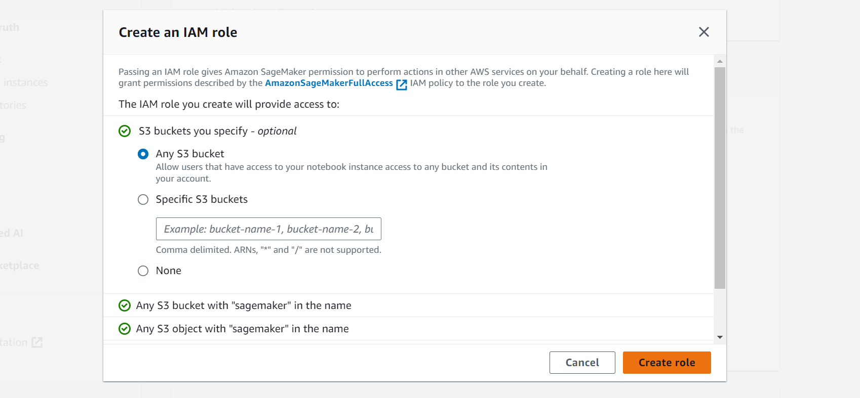

After Creating the role you will see below message in green Highlighted Box

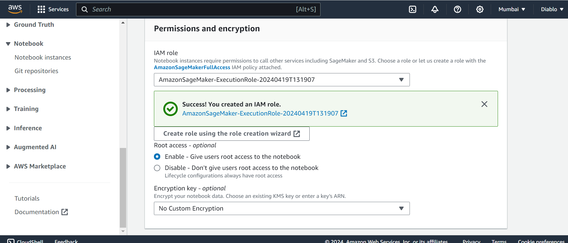

After filling all the options click on **Create Notebook Instance**

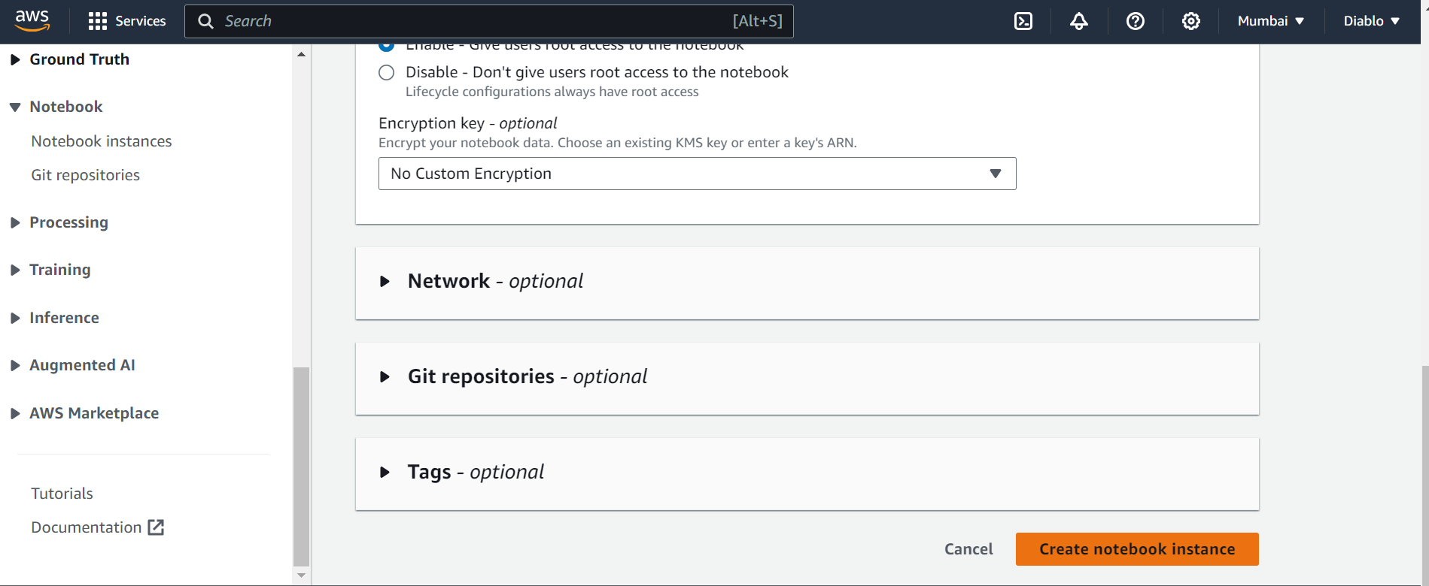

Once You clicked on the **Create Notebook Instance you will see below interface**

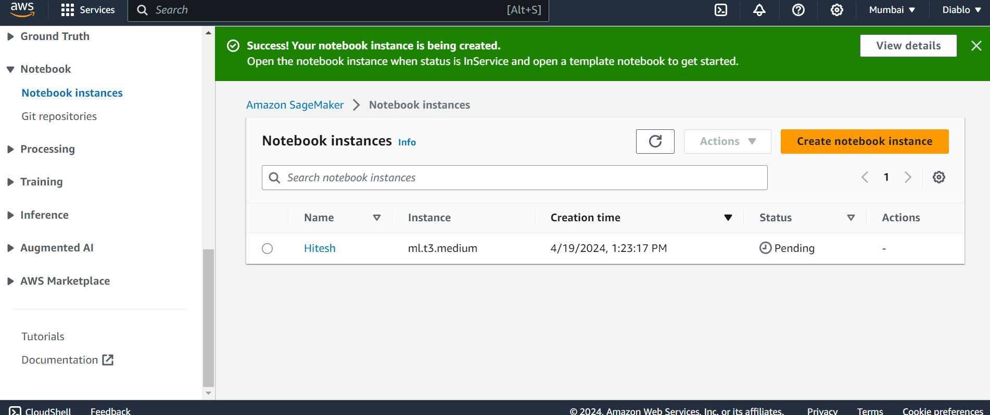

Now the status is pending after doing the refreshes after some time within the frame of one minute it will show the Inservice Status

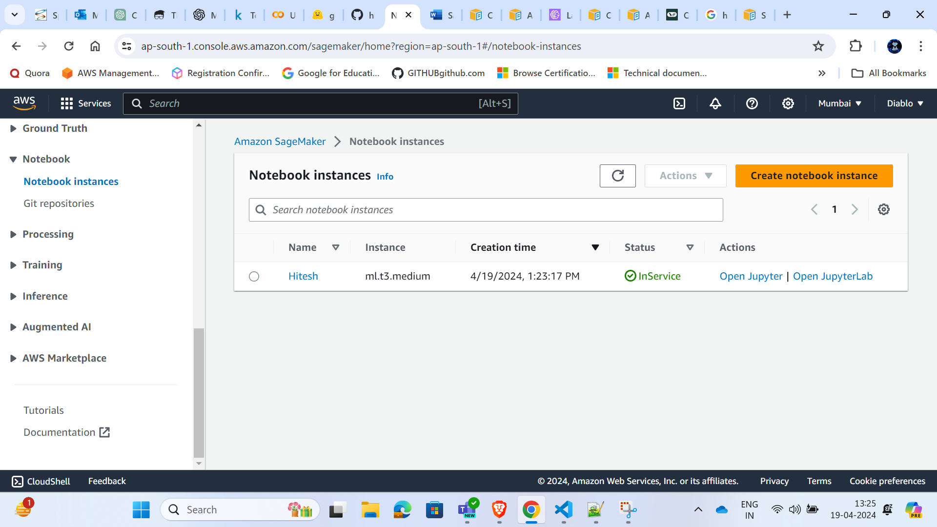

After getting the status as InService Click on **Open JupyterLab**

When the status of the notebook instance is InService, in the console, the notebook instance is ready to use. Choose **Open JupyterLab** next to the notebook name to open the classic Jupyter dashboard.

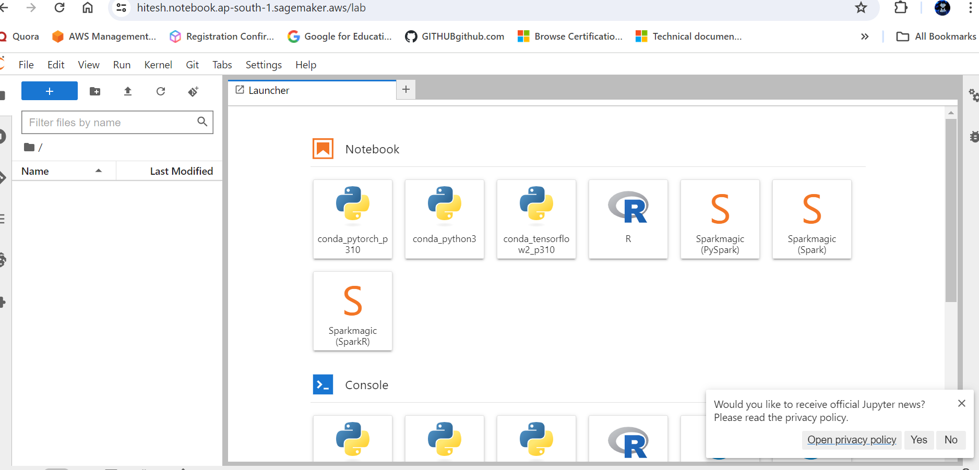

Doneee!!!!!!!!! You have Successfull Created the Notebook Instances.

**How to Update the Notebook instances**

You can update the tags of a notebook instance that is InService. To update any other attribute of a notebook instance, its status must be Stopped.

###### **To update a notebook instance in the SageMaker console:**

1. Open the SageMaker console at <https://console.aws.amazon.com/sagemaker/>.
2. Choose **Notebook instances**.
3. Choose the notebook instance you want to update by selecting it from the list.
4. If your notebook **Status** is not Stopped, select the **Stop** button to stop the notebook instance.

When you do this, the notebook instance status changes to Stopping. Wait until the status changes to Stopped to complete the following steps.

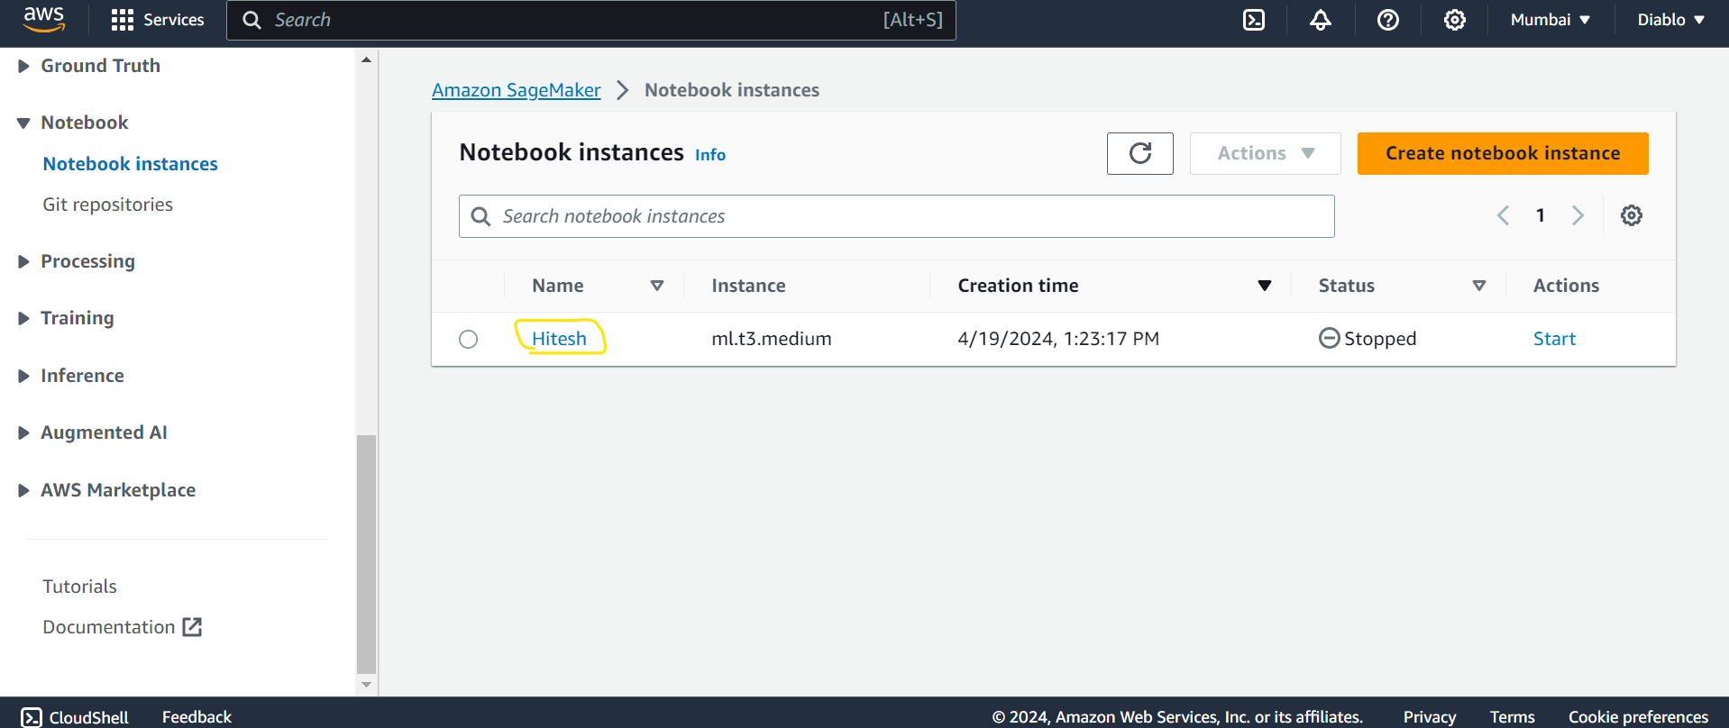

After Clicking the name of the instances you will see all the details of the notebook and its configurations now Select the **Edit** button to open the **Edit notebook instance** page.

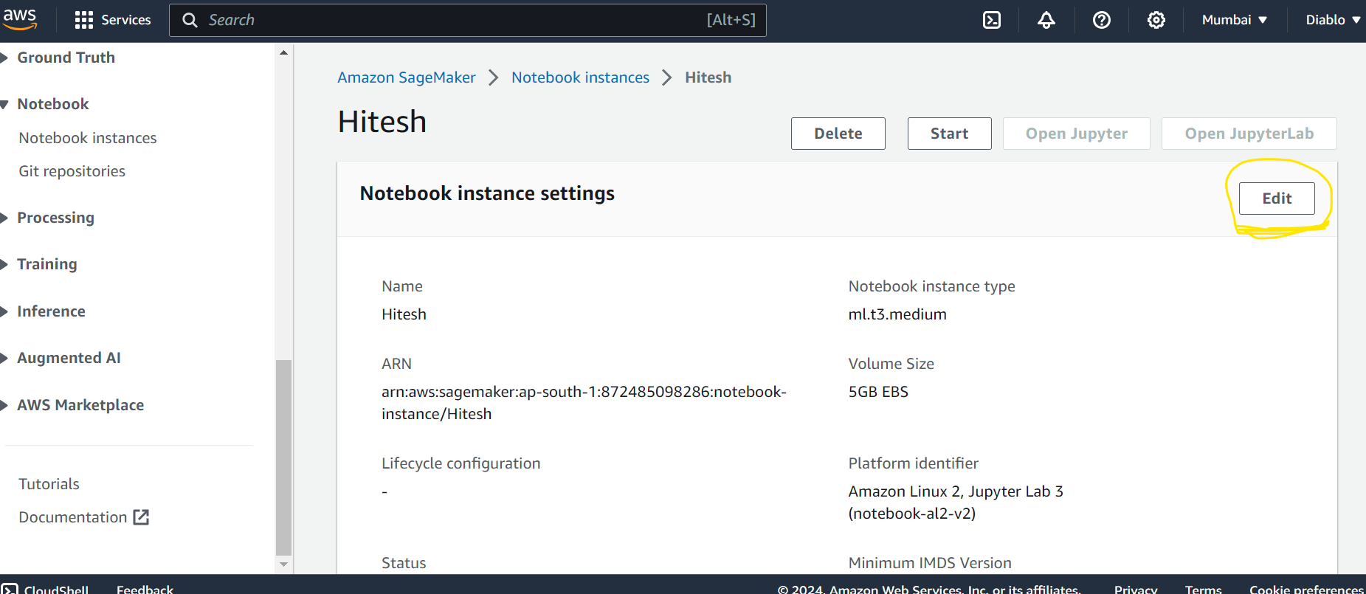

After Clicking on this you will see this below image here you can select the Notebook instance types from the dropdown menu.

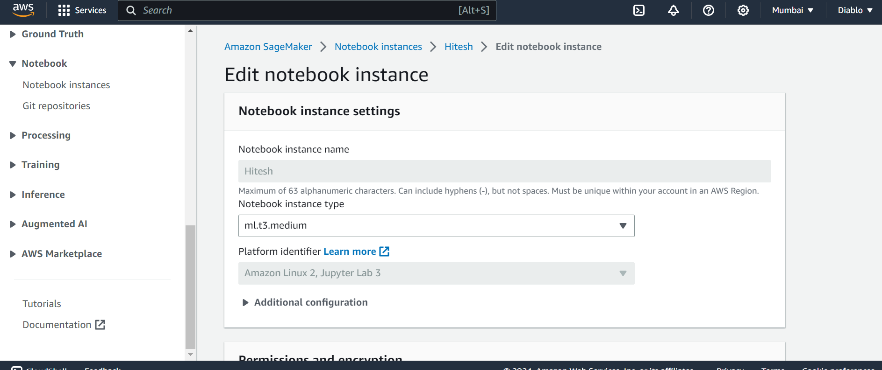

Click the **Additional configuration** which lets you specify the size, in GB, of the ML storage volume that is attached to the notebook instance. You can choose a size between 5 GB and 16,384 GB, in 1 GB increments. You can use the volume to clean up the training dataset or to temporarily store validation or other data.

For **Minimum IMDS Version**, select a version from the dropdown list. If this value is set to v1, both versions can be used with the notebook instance. If v2 is selected, then only IMDSv2 can be used with the notebook instance.

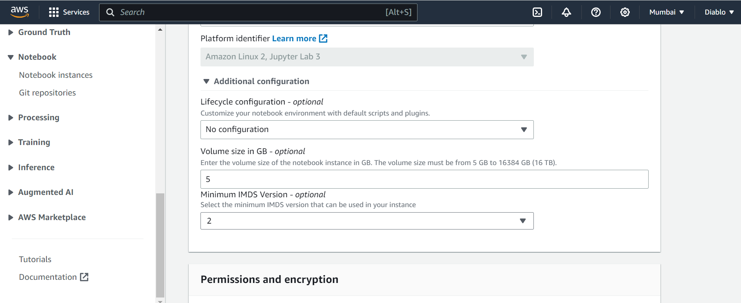

Update your notebook instance and select the **Update notebook instance** button at the bottom of the page when you are done to return to the notebook instances page. Your notebook instance status changes to **Updating**.

When the notebook instance update is complete, the status changes to Stopped

To Create instance with the help of Console

**aws sagemaker create-notebook-instance \**

**--notebook-instance-name** <notebook-instance-name> \

**--instance-type** <instance-type> \

**--role-arn** <role-arn> \

**--kms-key-id** <kms-key-id> \

**--tags** <tag-1>=<value-1>,<tag-2>=<value-2>

aws sagemaker create-notebook-instance: This is the command to create a new SageMaker notebook instance.

--notebook-instance-name <notebook-instance-name>:

This option specifies the name for the new notebook instance. Replace <notebook-instance-name> with the desired name for your notebook instance.

--instance-type <instance-type>:

This option specifies the type of instance to use for the notebook. Replace <instance-type> with the desired instance type. For example, ml.t2.medium, ml.t3.large, etc.

--role-arn <role-arn>:

This option specifies the Amazon Resource Name (ARN) of the IAM role that SageMaker will assume to perform tasks on your behalf. This role needs permissions to access other AWS services like S3. Replace <role-arn> with the ARN of your IAM role.

--kms-key-id <kms-key-id>:

This option specifies the KMS key ID used to encrypt data at rest. Replace <kms-key-id> with the ID of the KMS key you want to use.

--tags <tag-1>=<value-1>,<tag-2>=<value-2>:

This option allows you to tag your notebook instance with metadata in the form of key-value pairs. Replace <tag-1>=<value-1>,<tag-2>=<value-2> with the tags you want to assign to your notebook instance. For example, --tags Environment=Development,Owner=Hitesh.